In the meantime, please go to usegalaxy.org to register for an account. The process is super easy.

- From https://usegalaxy.org/ click on “Login or Register” from the black menu bar at the top
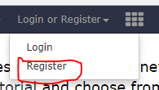
- You will proceed to a standard registration page which takes no time to complete. Make sure to choose a public name. Make all efforts to use something close to your name as possible. In the future this will be a way your shared workflows and published galaxy materials are accessible.
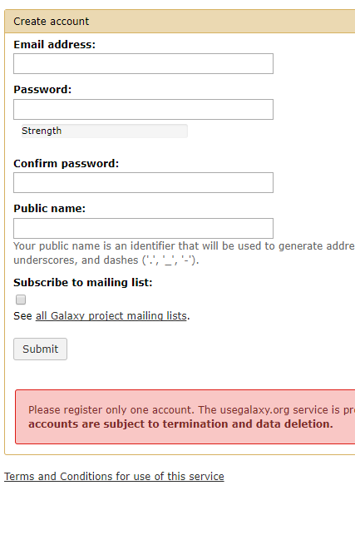
- Make sure to confirm your registration via email and save your login information in a safe place that you can easily access so you can use it the day of the workshop or when you need it.

